**Name: Hidy Refaey Saad**

**Group: 8**

**SEC: 46**

**P/N: 2**

**Subject:-**

**What is the Internet of Things? How the IoT works, and more**

**Get Hub Link:-**

[**https://github.com/hidyrefeay/html.project.repository**](https://github.com/hidyrefeay/html.project.repository)

**Get Hub page (published website)**

[**https://hidyrefeay.github.io/html.project.repository/**](https://hidyrefeay.github.io/html.project.repository/)

**Screen shots:-**

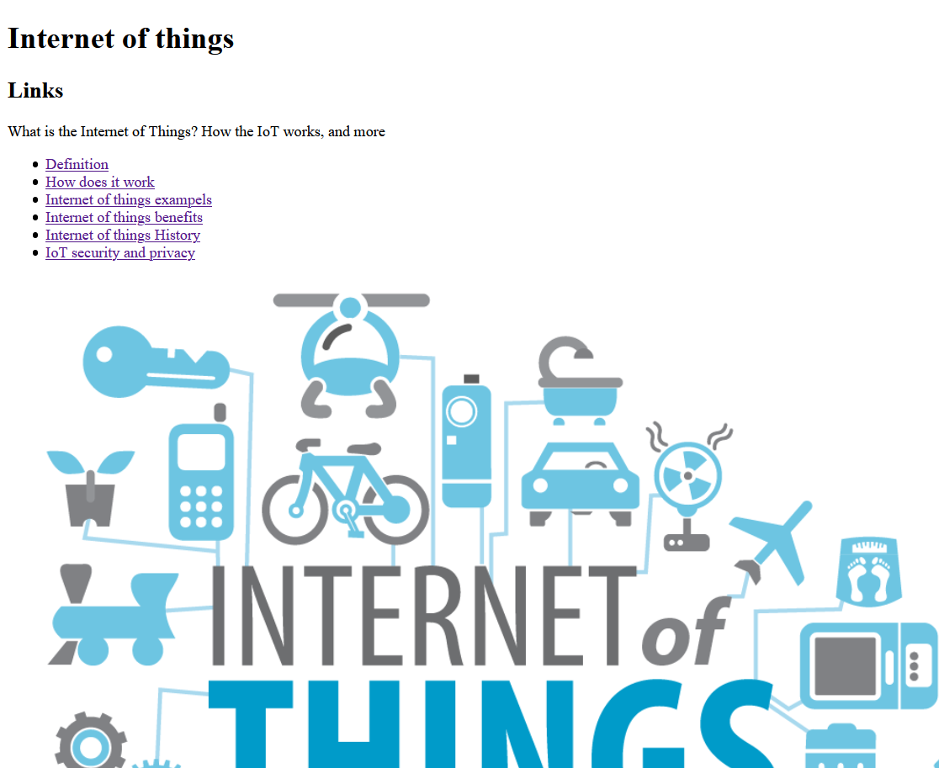

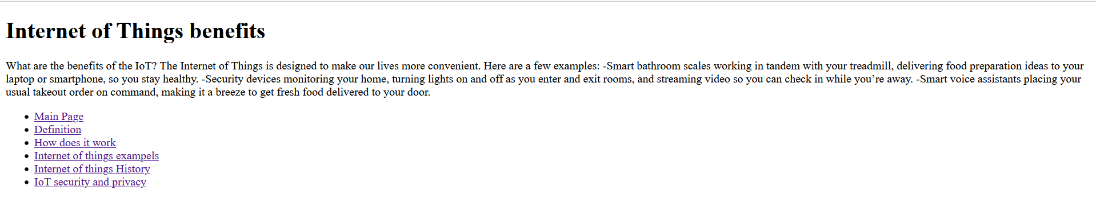

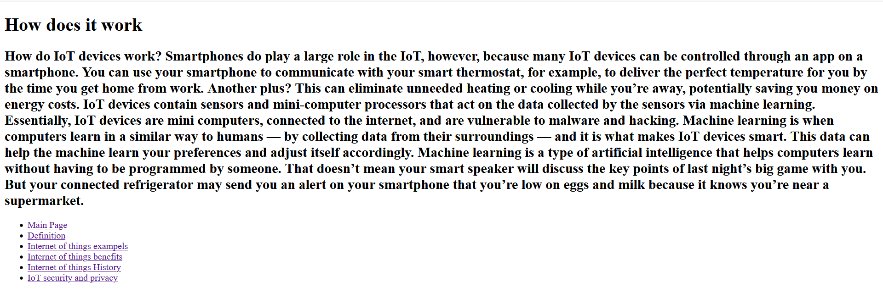

Source Code:-

